|  |  |  |  |  |  |
| --- | --- | --- | --- | --- | --- |
| COMPANY | | | | | |
| Key Type | Optionality | Column Name | Data Type | Length | Constraints |
| PK | * | Company_Id | integer |  | Unique Identifier |
| UK | * | Name | varchar | (25) | Unique Identifier |
| UK | * | Phone_Name | integer |  | Unique Identifier |
| UK | * | Email | varchar | (25) | Unique Identifier |
|  | * | Address | varchar | (25) |  |

**Company Table**

INSERT INTO Company VALUES

(1,'Oasis', 1234567890, 'oasis.hardware@gmail.com', '45 queen street west');

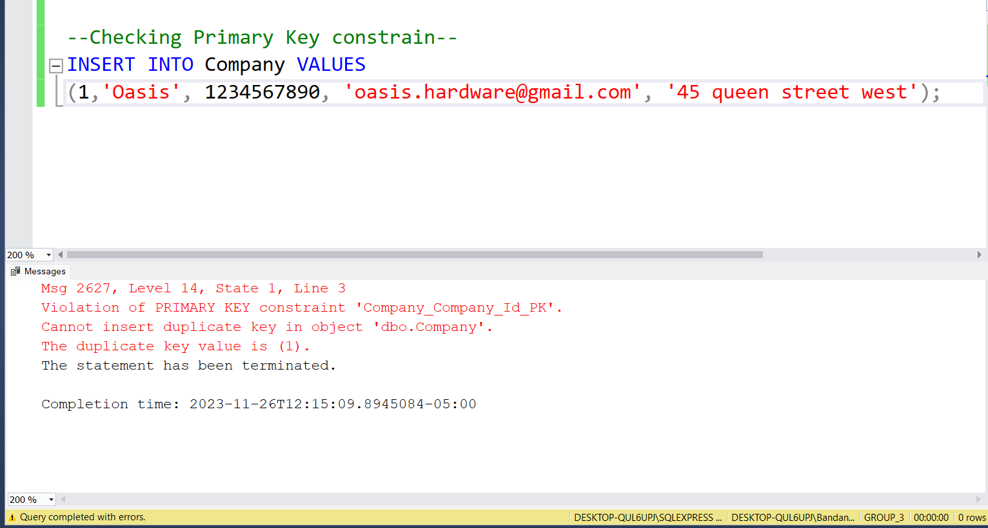

Figure 1 : Checking Primary Key Constraint for Company_Id



Figure 2 : Checking Unique Constraint for Name

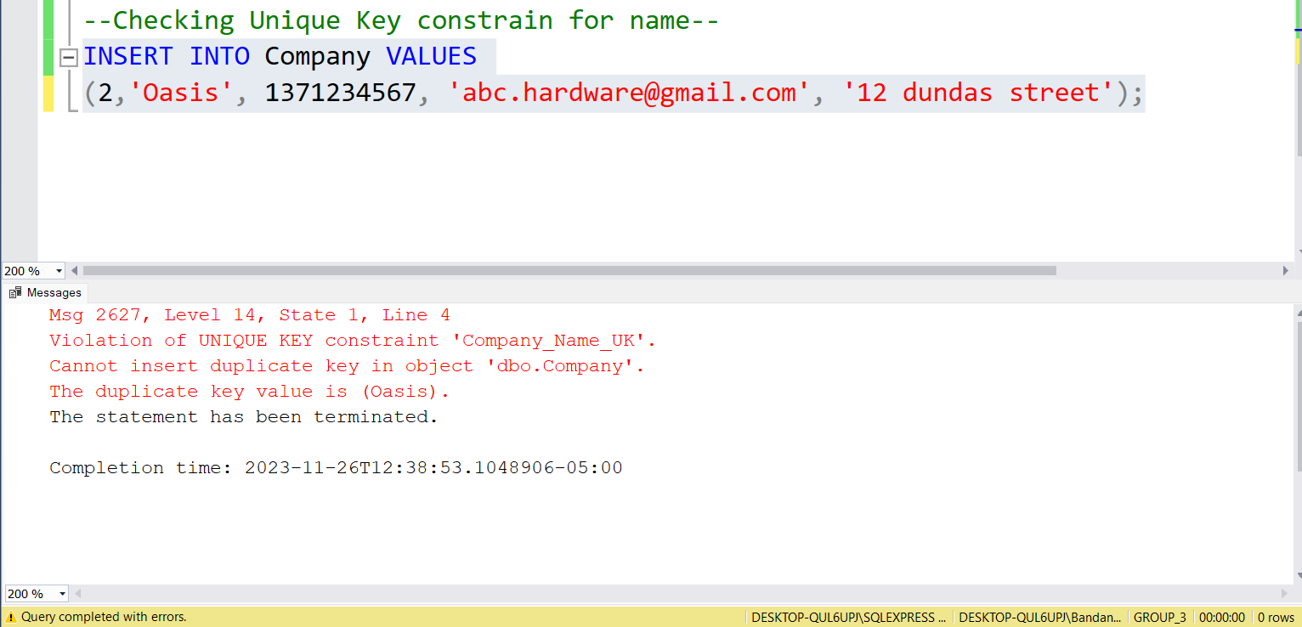

Figure 3 : Checking Unique Constraint for Phone_Number

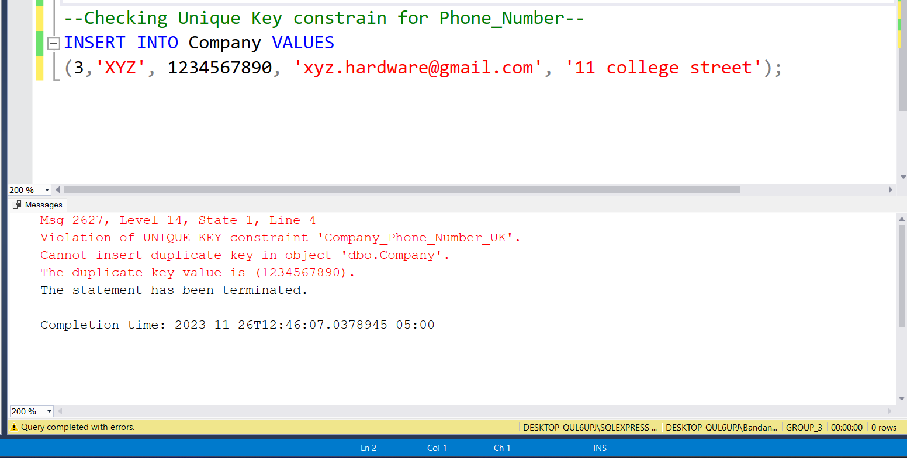

Figure 4 : Checking Unique Constraint for email

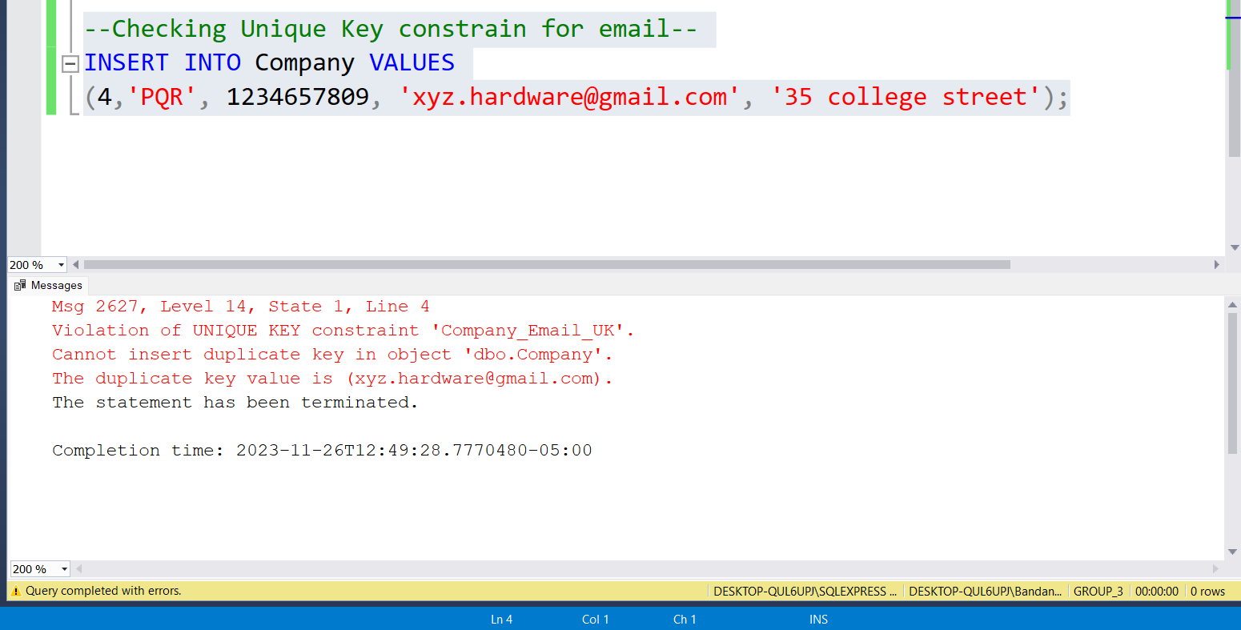

|  |  |  |  |  |  |
| --- | --- | --- | --- | --- | --- |
| WAREHOUSES | | | | | |
| Key Type | Optionality | Column Name | Data Type | Length | Constraints |
| PK | * | Warehouse_Id | integer |  | Unique Identifier |
| FK | * | Company_Id | integer |  |  |
| FK | 0 | Warehouse_Manager_ID | integer |  | Must be a valid Employee |
|  | 0 | Phone_Number | varchar | (10) |  |
| UK | * | Email | varchar | (50) | Unique Identifier |
|  | * | Address | varchar | (50) |  |

**Warehouses Table**

INSERT INTO Warehouses (Warehouse_Id ,Company_Id ,Phone_Number ,Email , Address)

VALUES (1,1, 1234567890, 'oasis.hardware@gmail.com', '12 college street');

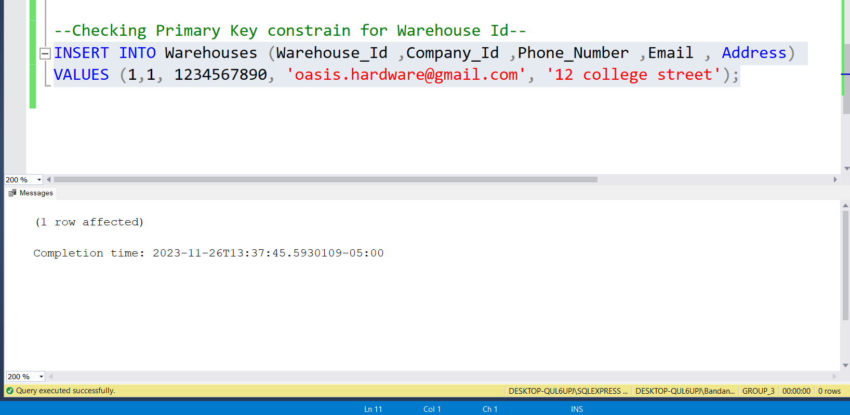

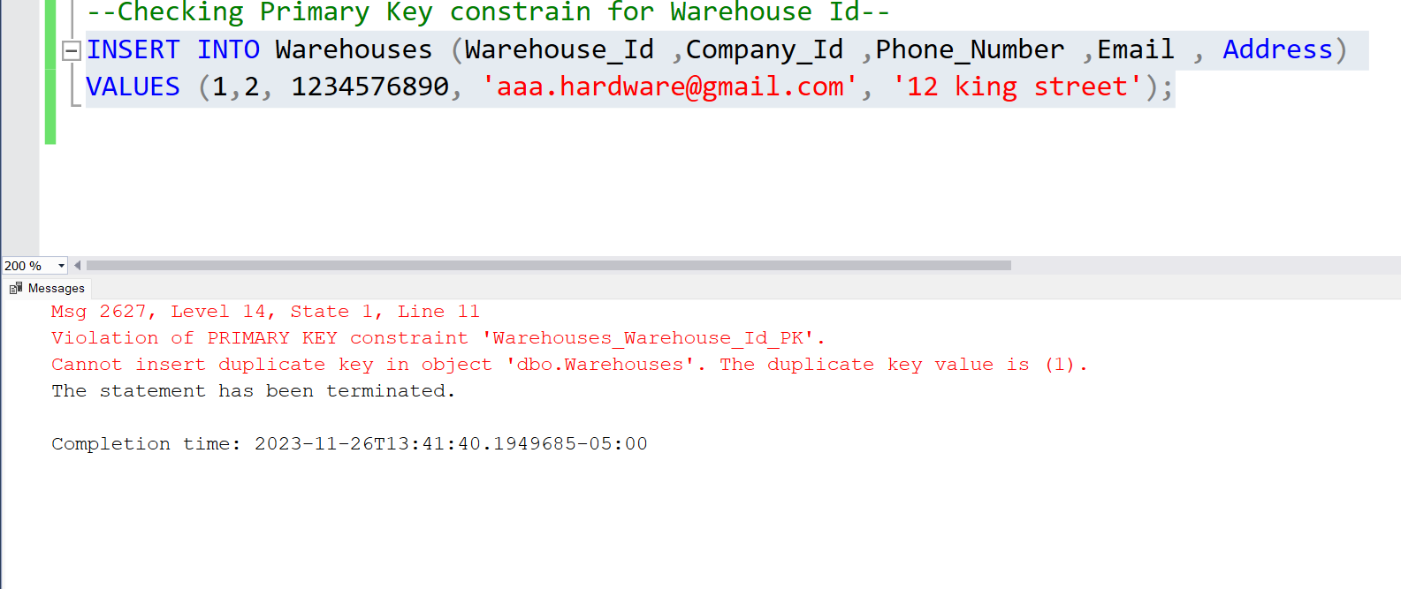

Figure 6: Checking Primary Key Constraint for Warehouse _ID

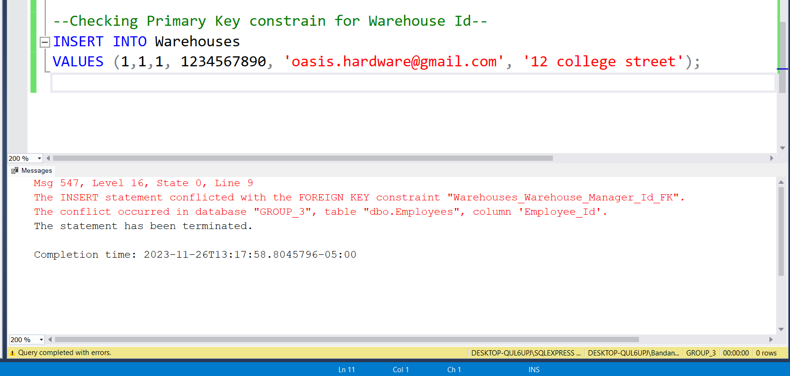

Figure 7: Checking Foreign Key Constraint for Warehouse_Manager_ID

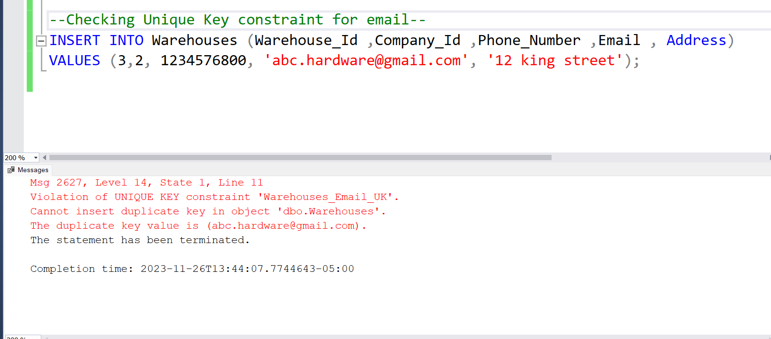

Figure 8: Checking Unique Key Constraint for email